Part 3 - Detailed Design

Architecture-
The architecture best suits our project is MVC.

MVC Architecture in our project:

- Model:
  - Manages user profiles, dietary preferences, allergies, and personal settings.
  - Stores and retrieves structured data such as inventory items, sessions, and previous meal suggestions using an SQL database.
  - Handles communication with external services and the AI model.
- View:
  - Implemented as a Telegram Bot interface.
  - Receives user input like text messages and fridge photos.
  - Displays outputs to the user such as detected ingredients, meal suggestions, and cooking instructions.
- Controller:
  - Acts as a bridge between the Model and the View.
  - Handles user requests, processes input, and activates the relevant workflow.
  - Coordinates the AI pipeline (image → ingredients → meal generation), updates the database, and sends results back to the user.

Data Storage:
- User profiles, preferences, inventory, and session history are stored in an SQL database.
- Generated meal suggestions and feedback are stored for history and improvement.
- Configuration parameters (API keys, model settings) are stored securely in configuration files / environment variables.

Graphic Description

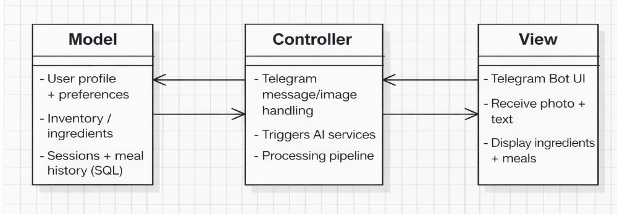

data description:

  - User Profiles Table – A SQL table containing personalized settings and goals for each user:
  - user_id
  - calorie_goal
  - meals_per_day
  - diet mode
  - allergies
  - inventory Table – A SQL table that tracks the current food items available in the user's kitchen:
  - user_id
  - ingredient_name
  - detected_timestamp
  - Meal History Table – A SQL table recording all meals suggested to and consumed by the user:
  - user_id
  - meal_name
  - calories
  - timestamp
  - recipe_instructions ("how-to-cook" guide)

  - Daily Summaries Table – A SQL table used for fast analytics, summaries, and trend graphs:
  - user_id
  - date
  - total_calories_consumed
  - total_meals_count

User interface:

  - Set up personal diet profile: Input and save settings such as calorie goals, meals per day, and dietary preferences like Vegan mode.
  - Upload fridge/pantry images: Send single or batch photos of food items to the bot for ingredient extraction .
  - Review detected ingredients: View the automated list of items the AI recognized from the images .
  - Manually correct inventory: Add missing ingredients or remove incorrectly identified items through text commands.
  - Generate meal suggestions: Request exactly three unique meal options based on the current available ingredients.
  - View cooking instructions: Display step-by-step "how-to-cook" guides for a selected meal suggestion.
  - Display nutrition analytics: Generate and view daily summaries or visual graphs showing calorie consumption and goal progress.
  - Manage food inventory: View or reset the list of stored ingredients currently saved in the database.

Programming Languages and Tools -
NutriVision is developed in Python, with a local backend server that connects Telegram to the core logic. It uses the latest GPT multimodal model for ingredient recognition from image batches and for generating three meal suggestions plus cooking instructions. User data is stored in an SQL database, and nutrition/calorie information is fetched through external food APIs such as OpenFoodFacts using standard web requests and JSON.

interface design:

